DOVE REQUIREMENTS
Order Information
Project/Customer:
Export Manager:
Luminaire Information
Article:
Model number:
Quantity:
Luminous flux: |  |  |  | [lm]
Warranty: |  |  |  | [years]
Screws
Regular torx screws
Vandal proof screws
Screws must be colored
End cap
Both end caps mounted
One end cap mounted
Dimming
DALI
1-10 V
Corridor function*
*Program needed

Corridor Function parameters.
Configuration type (choose one)
 |  | Presence level: |  | 100%
 |  | Absence level: |  | 10%
 |  | Fade-in time: |  | 00:00:00.000
 |  | Fade-out time: |  | 00:00:30.000
 |  | Run-on time: |  | 00:00:00
 |  | Never off: |  | YES
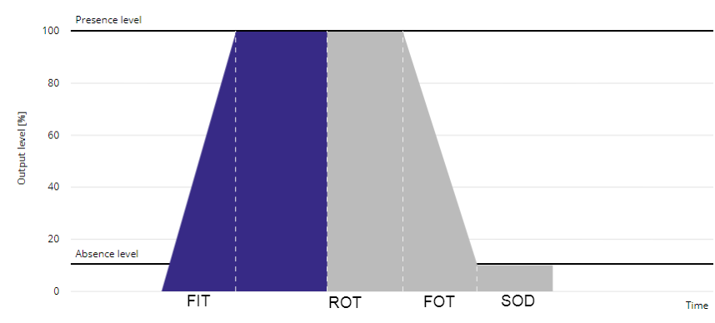
Presence level | [1-100%]
Absence level | [0-100%]
Fade-in time | [0-9600s] |  | FIT
Run-on time | [0-2550s] |  | ROT
Fade-out time | [0-9600s] |  | FOT
Switch-off delay | [0-2540s] |  | SOD
Never off |  |  |  | If YES, then no SOD needed!

Other Requirements

