LEAF SLIM REQUIREMENTS
Order Information
Project/Customer:
Export Manager:
Luminaire Information
Article:
Model number:
Quantity:
Luminous flux: |  |  |  | [lm]
Warranty: |  |  |  | [years]
Cables
2x1.5mm² (x2.5m) open end
5x1.5mm² (x2.5m) open end
2x1.5mm² (x2.5m) with plug
2x1.5mm² (x2.5m) Wago Winsta (770-1172) 2-way plug
5x1.5mm² (x2.5m) Wago Winsta (770-1115) 5-way plug
2x1.5mm² (x2.5m) Ensto (NAC21S.W) 2-way plug
5x1.5mm² (x2.5m) Ensto (NAC51S.W) 5-way plug
Other
Mounting
Pre-mounted suspension details
Surface mount set
Other

Driver
Loop through (Tridonic by default)
Dimming
DALI
1-10 V
Corridor function*
*Program needed

Corridor Function parameters.
Configuration type (choose one)
 |  | Presence level: |  | 100%
 |  | Absence level: |  | 10%
 |  | Fade-in time: |  | 00:00:00.000
 |  | Fade-out time: |  | 00:00:30.000
 |  | Run-on time: |  | 00:00:00
 |  | Never off: |  | YES
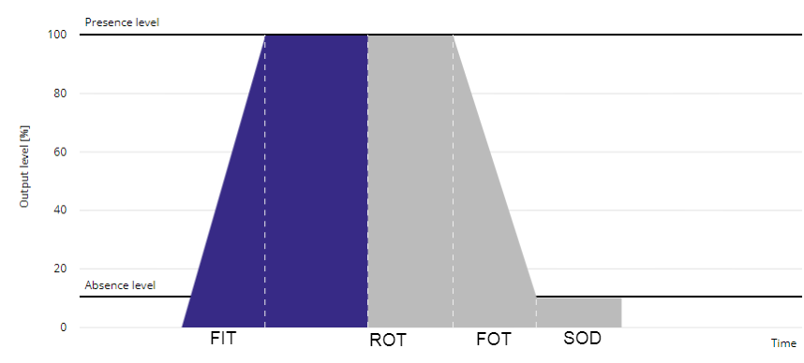
Presence level | [1-100%]
Absence level | [0-100%]
Fade-in time | [0-9600s] |  | FIT
Run-on time | [0-2550s] |  | ROT
Fade-out time | [0-9600s] |  | FOT
Switch-off delay | [0-2540s] |  | SOD
Never off |  |  |  | If YES, then no SOD needed!

Other Requirements

